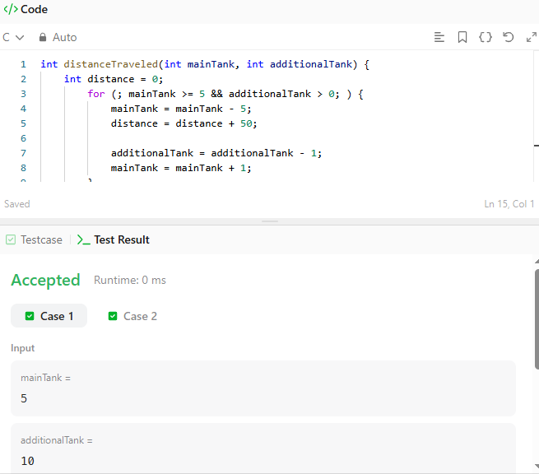

CODE-

int distanceTraveled(int mainTank, int additionalTank) {
int distance = 0;
for (; mainTank >= 5 && additionalTank > 0; ) {
mainTank = mainTank - 5;
distance = distance + 50;

additionalTank = additionalTank - 1;
mainTank = mainTank + 1;
}
distance = distance + (mainTank * 10);
return distance;
}

LINK-

https://leetcode.com/problems/total-distance-traveled/

